# Conversational Log

This document is going to look at the conversation logs of the technology stock bot and highlight any key implementation.

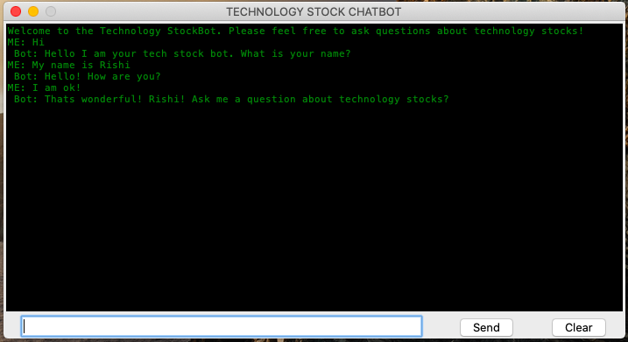

Rule based component using AIML rules using <think>, <get> and <set> tags.

Similarity based component using bag words, Tf-idf and cosine similarity on the question and answers in the csv file.

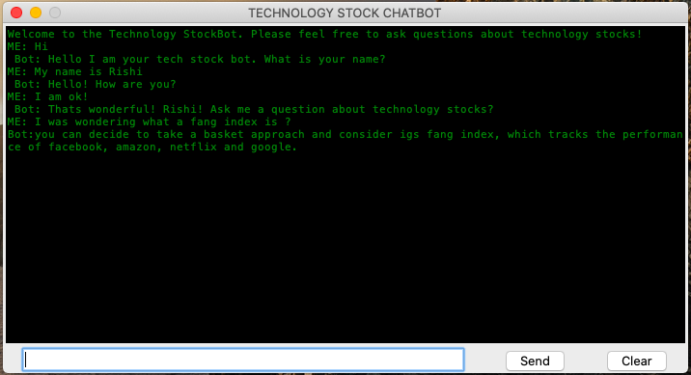

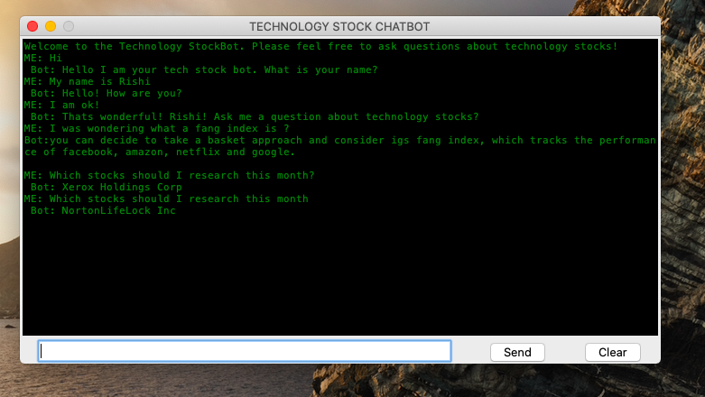

Rule based component using AIML rules using <random> and <li>.

Similarity based component using bag words, Tf-idf and cosine similarity on the question and answers in the csv file.

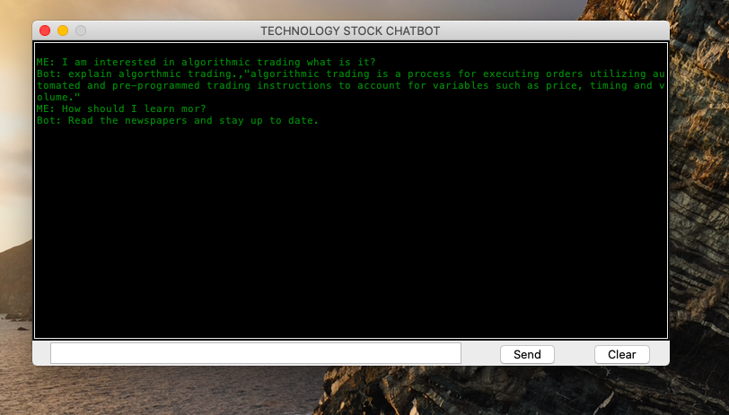

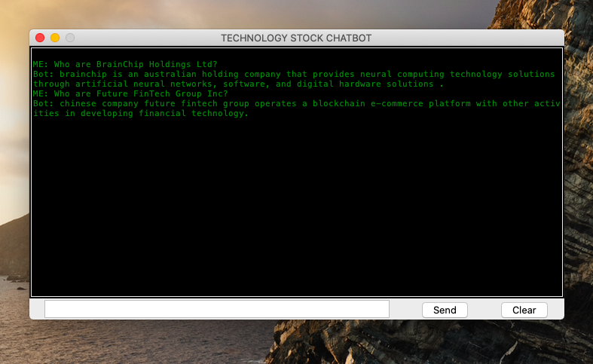

Similarity based component using bag words, Tf-idf and cosine similarity on the question and answers in the csv file.

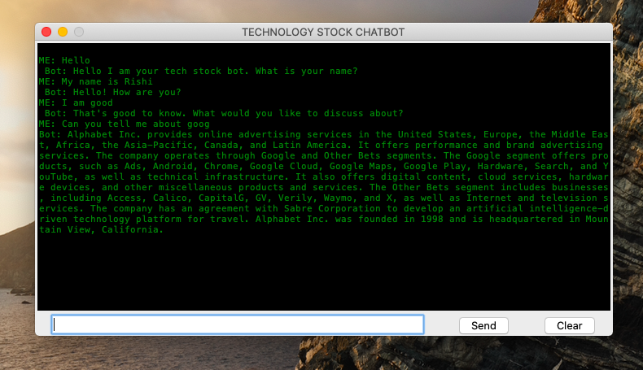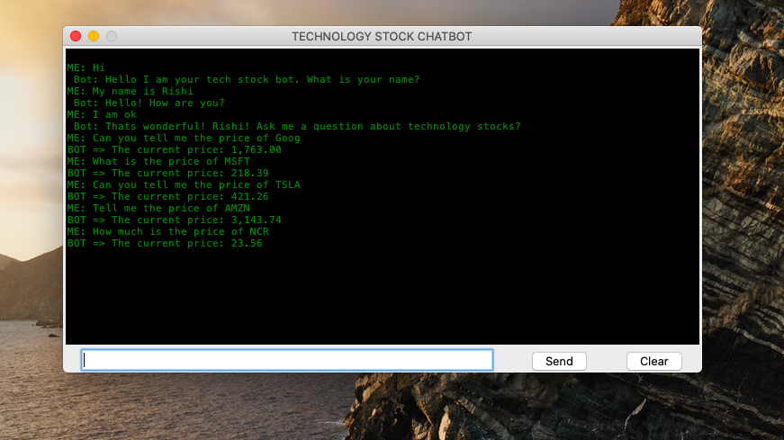

Rule based component using AIML rules using <star> tag and scraping yahoo finance to get information about company profiles.

Rule based component using AIML rules using <star> tag and scraping yahoo finance for live prices.

Similarity based component using bag words, Tf-idf and cosine similarity on the question and answers in the csv file.

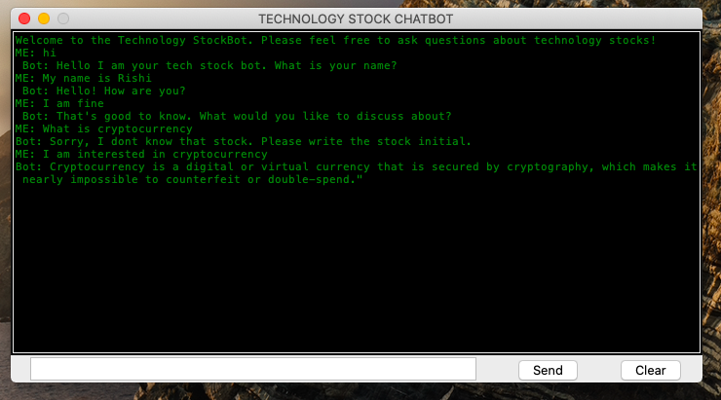

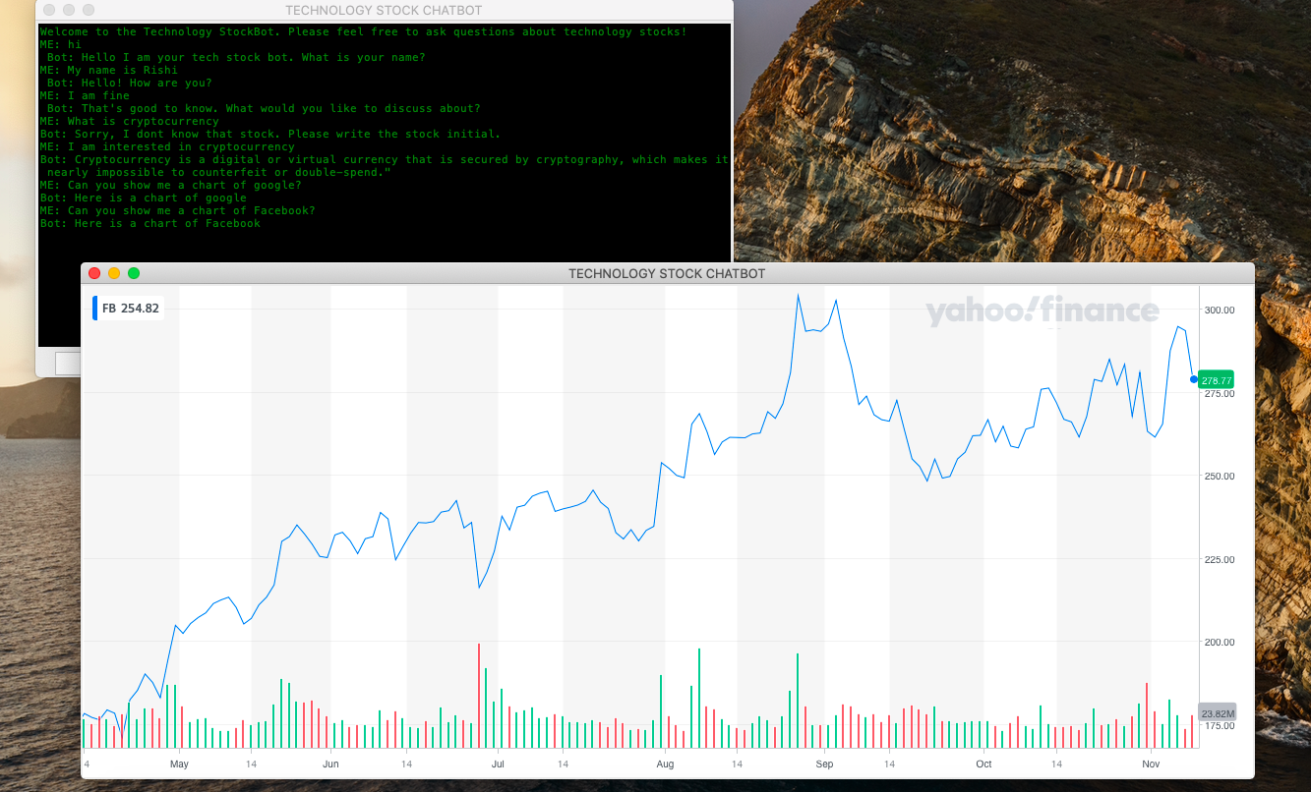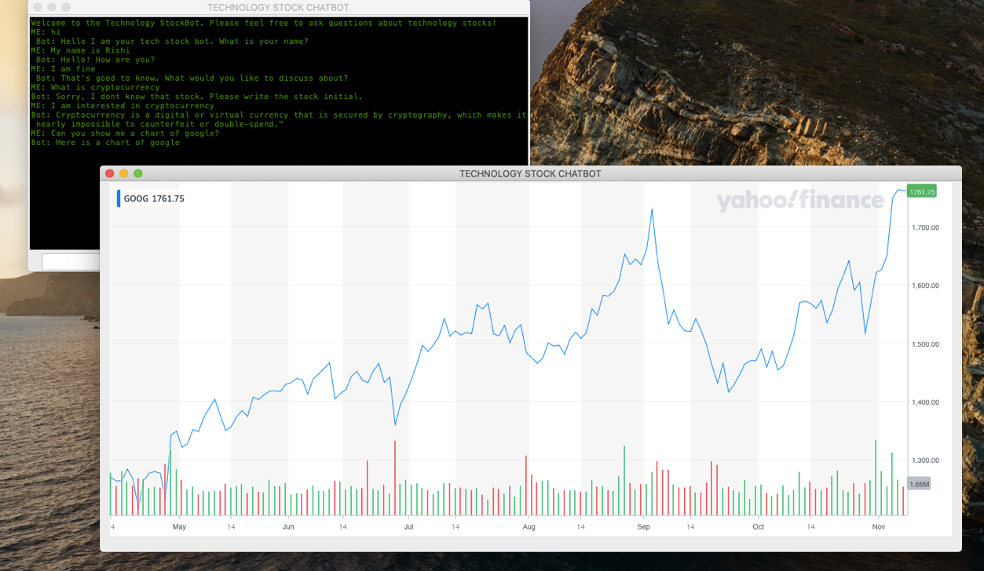

Rule based component using AIML rules using <star> tag and opening non-textual data.

Rule based component using AIML rules using <star> tag and opening non-textual data.

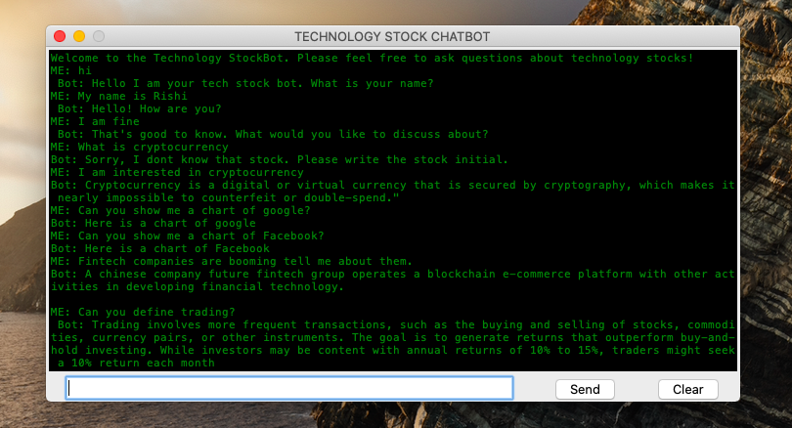

Similarity based component using bag words, Tf-idf and cosine similarity on the question and answers in the csv file. Bot was asked about fintech companies.

Rule based component using AIML rules, basic tags are used to define trading.